姓名 | 水玙阳
教育经历 | 2024~今，南方科技大学，智能制造与自动化，本科
电子邮箱 | 12411114@mail.sustech.edu.cn
个人照片 | 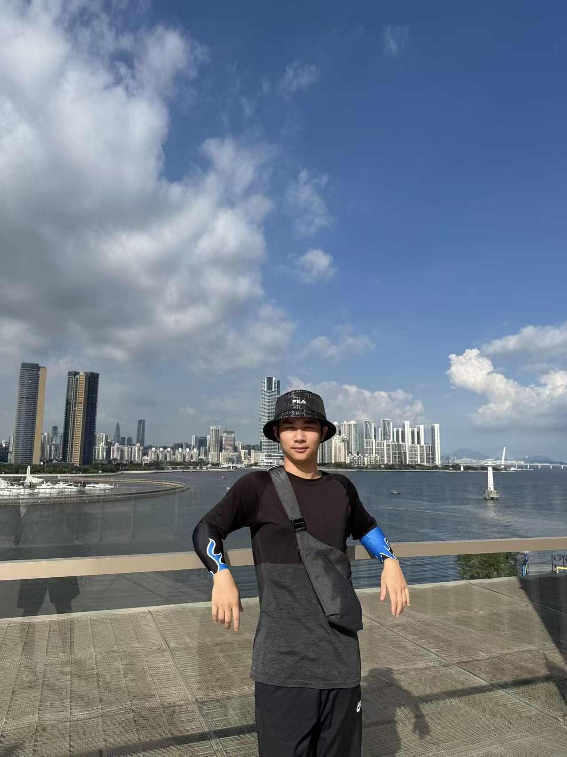
研究领域
自我介绍 | I'm Shui Yuyang, a 24th grade undergraduate student at Southern University of Science and Technology. I joined Professor Yue Tianqi's research group in 2025. I'm proficient in modular programming and 3D modeling. I'm currently devoting myself to the study of basic knowledge in the field of mechanical automation.
论文发表情况

